**Lab 3: *Virtual Machine Set-up* (2%)**

***Lab Report Submission***

**Name: Khai Phan**

**Student Number: 100901164**

**Important Notes:**

This lab document template should be used for the reporting your answers for Lab 3.

**Operating System Installation**

kphan6_L3_VM_Install

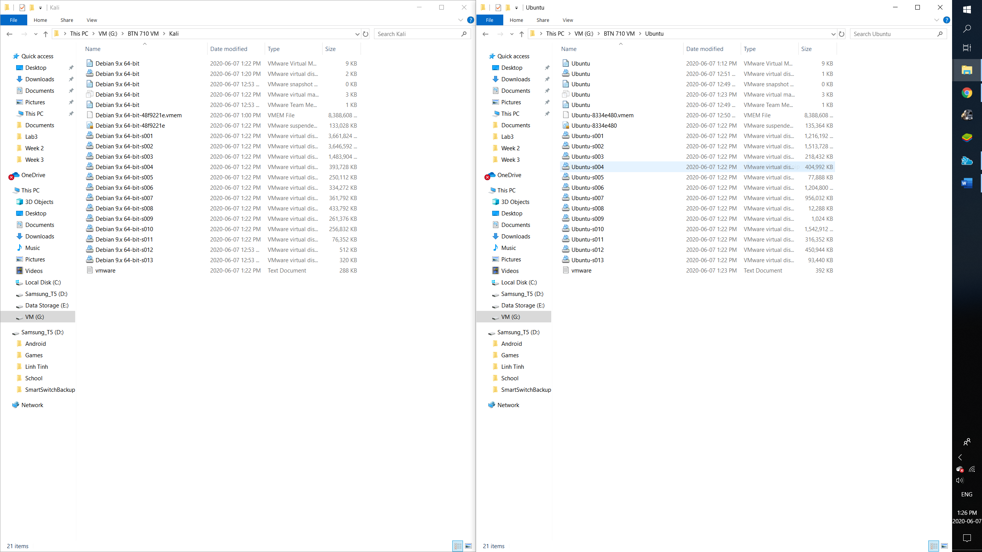

kphan6_L3_Ubuntu_VM_Install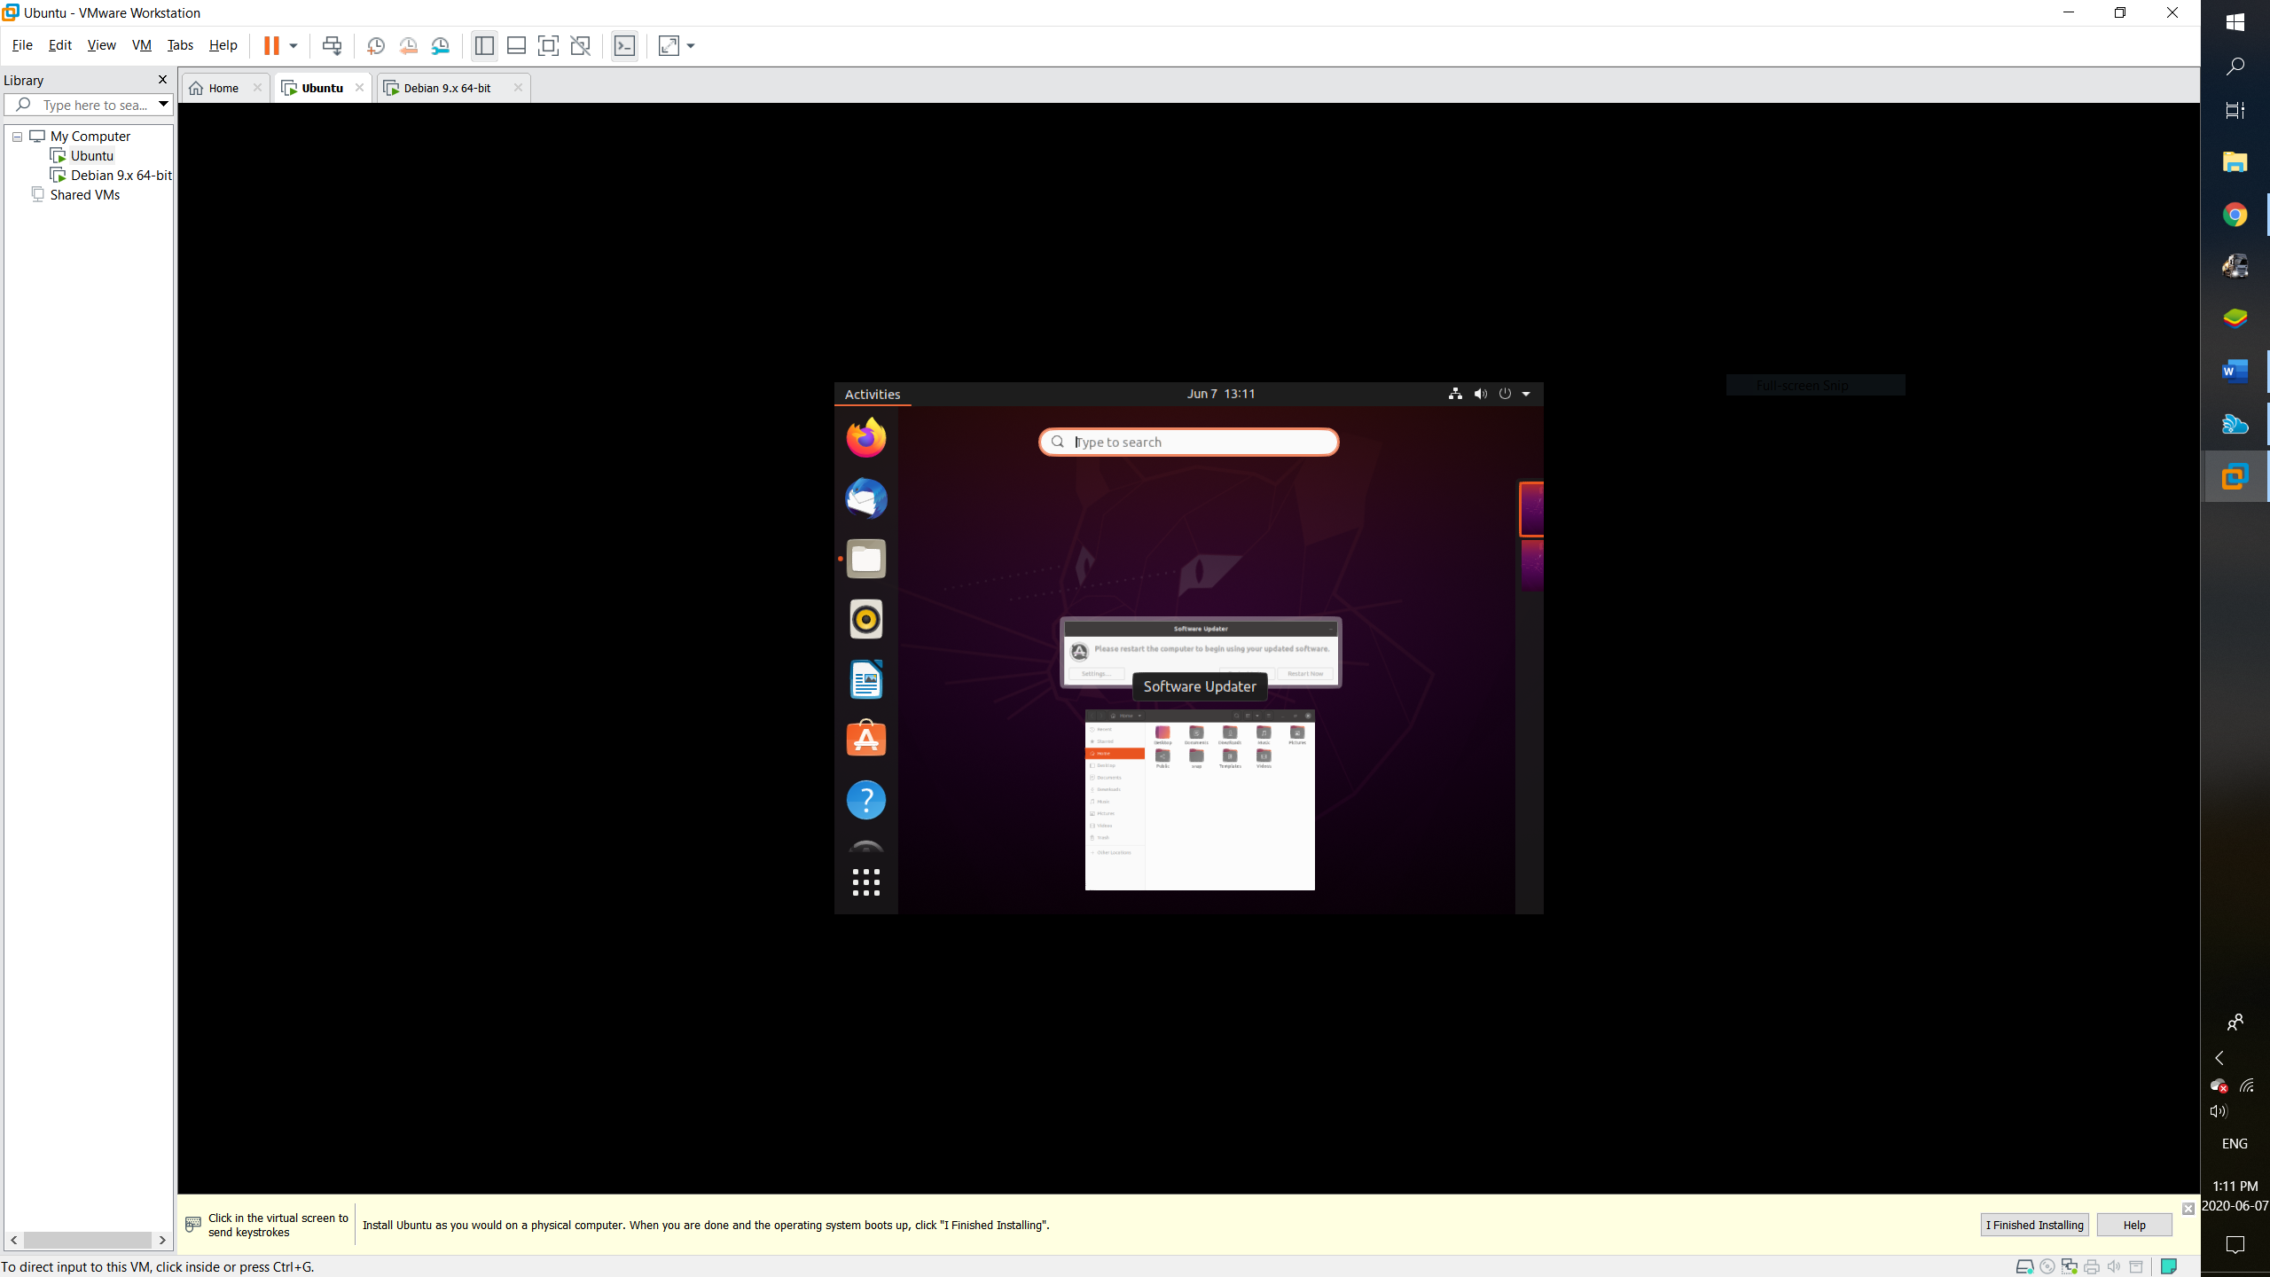

kphan6_L3_Kali_VM_Install

